THE DRAWING(S) AND THE INFORMATION CONTAINED HEREIN ARE THE PROPERTY OF WOOJIN INDUSTRIAL SYSTEMS CO., LTD. THEY SHALL NOT BE DISCLOSED, REPRODUCED OR USED, IN ANY MANNER WITHOUT THE PRIOR WRITTEN CONSENT OF WOOJIN INDUSTRIAL SYSTEMS CO., LTD. |  | DESCRIPTION  OF  CCP USER INTERFACES
 |  | R  E  V  I  S  I  O  N | 5 | Sep. 6, 2012 |  | Contents Revised |  |  | D.B. LEE | D.S. JANG | B.J. JONE | E.K. LEE
 |  | R  E  V  I  S  I  O  N | 4 | Aug. 14, 2012 |  | Contents Revised |  |  | D.B. LEE | D.S. JANG | B.J. JONE | E.K. LEE
DISTRIBUTION |  | R  E  V  I  S  I  O  N | 3 | June 20, 2012 |  | Contents Revised |  |  | D.B. LEE | D.S. JANG | B.J. JONE | E.K. LEE
 |  | R  E  V  I  S  I  O  N | 2 | June 4, 2012 |  | Contents Revised |  |  | D.B. LEE | D.S. JANG | B.J. JONE | E.K. LEE
 |  | R  E  V  I  S  I  O  N | 1 | May 4, 2012 |  | Contents Revised |  |  | D.B. LEE | D.S. JANG | B.J. JONE | E.K. LEE
 |  | R  E  V  I  S  I  O  N | 0 | Mar. 21, 2012 |  | First Issued |  |  | M.H. JIN | D.B. LEE | D.S. JANG | B.J. JONE
 |  | R  E  V  I  S  I  O  N | No. | ISSUED  DATE |  | REVISION NOTE |  |  | DESIGNED | CHECKED | APPROVED | REVIEWED
 |  |  |  |  |  |  |  |  | ENGINEERING |  |  | PM
 |  | PM |  |  | REVIEWED |  | E.K. LEE |  | CUSTOMER :
 |  | ENGINEERING |  |  | APPROVED |  | B.J. JONE |  | HYUNDAI ROTEM COMPANY
 |  |  |  |  | CHECKED |  | D.S. JANG
 |  |  |  |  | DESIGNED |  | D.B. LEE |  | PROJECT :
 |  | ISSUED DATE |  |  | September 6, 2012 |  |  |  | DENVER RTD EAGLE P3  COMMUNICATION SYSTEM
 |  | ISSUED BY |  |  | R & D CENTER
 |  | PROJECT NO. |  |  | P2011-020
 |  | ORDER NO. |  |  | P110701149 |  |  |  | 
 |  | DOCUMENT NO. |  |  |  |  |  | REVISION
 |  | 42A-2012-0055 |  |  |  |  |  | 5
TOTAL |  |  |  |  |  |  |  | 5
REVISION RECORD
Rev. No. | PAGE | Details |  | Date
Rev. No. | PAGE | FROM | TO | Date
0 |  | First Issued |  | March 21, 2012
1 | ALL | Previous Figures | Revised Figures | May 4, 2012
2 | ALL | Previous Figures | Revised Figures | June 4, 2012
3 | ALL | Previous Figures | Revised Figures | June 20, 2012
4 | ALL | Previous Figures | Revised Figures | August 14, 2012
5 | 12 | Title Vehicle Failure Information | Change Password Screen | September 6, 2012
5 | 17, 18 | Previous Figures | Revised Figures | September 6, 2012
Table of Contents

1. CCP Initial Screen 3
2. Route Number Input 3
3. Crew ID Input 4
4. Initial screen after setting a Route Number / Crew ID 5
5. Destination information, Destination arrival time, Delay time, and Departure station, This stop, and Next stop Information Display 6
6. Configuration Initial Screen 7
7. Interior / Exterior Speaker Volume Setting (* to be password protected) 8
8. LCD brightness control 9
9. System initialization : pre-set Train Number / Crew ID initialization 9
10. Simulation Interval Setting 10
11. C/I number setting(* to be password protected) 11
12. Change Password Screen 12
13. Vehicle failure information display 13
13.1 Married A vehicle failure information display 14
13.2 Married B vehicle failure information display 15
14. HELP Initial Menu Display 16
14.1 HELP on the HOME screen 16
14.2 HELP on the ROUTE screen 17
14.3 HELP on the CREW screen 18
14.4 HELP on the STOPS screen 18
14.5 HELP on the CONFIG. screen 19
14.6 HELP on the CHECK screen 20
14.7 HELP on the PEI screen 20
14.8 HELP on the CM screen 21
15. PEI initial screen 21
15.1 PEI CALL display of Married A 23
15.2 PEI CALL display of Married B 24
16. PR information display 24
17 Simulation Mode Display 25

CCP Initial Screen
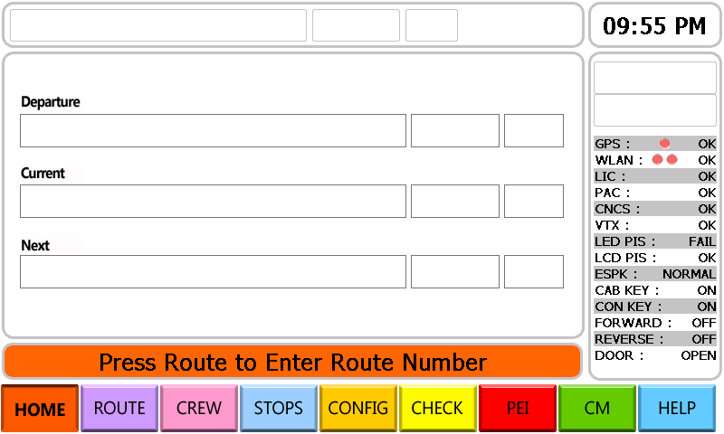

Route Number Input
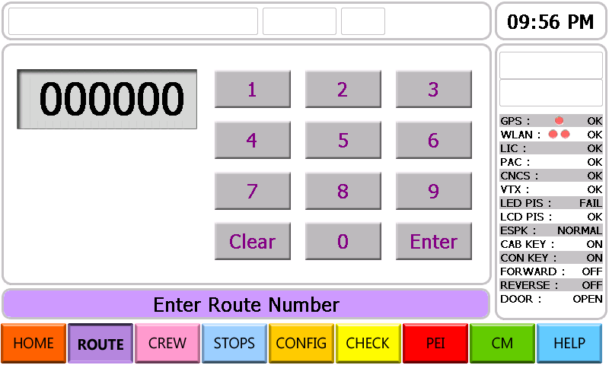
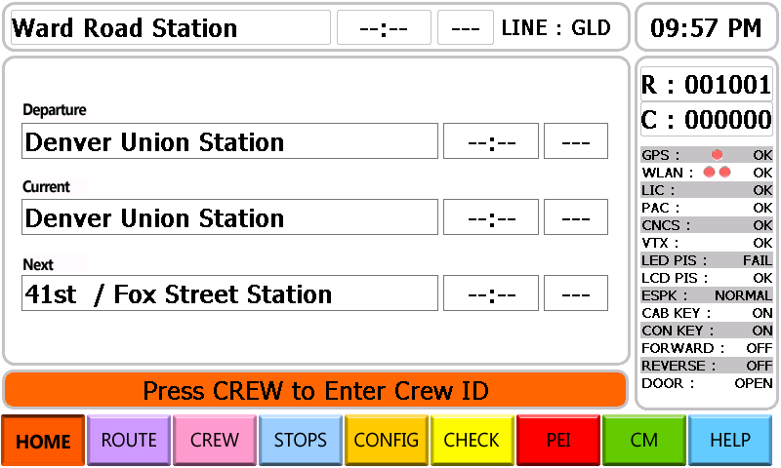

3. Crew ID Input
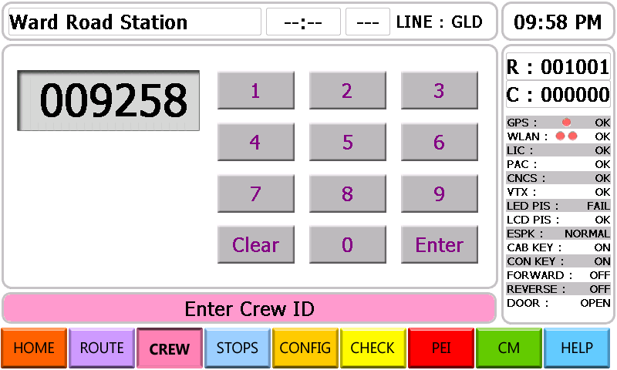

4. Initial screen after setting a Route Number / Crew ID
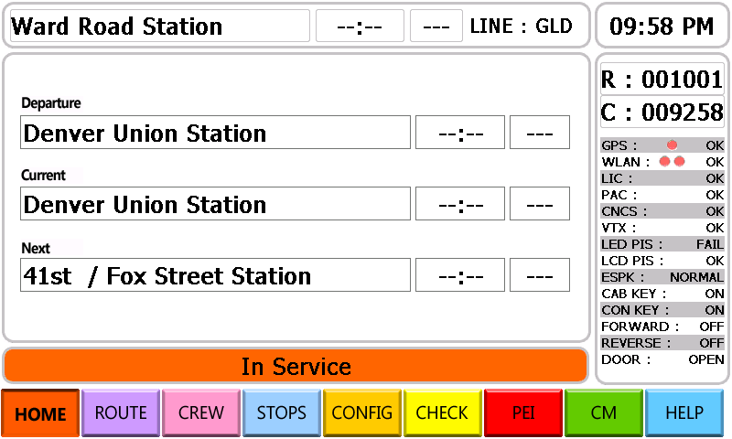

5. Destination information, Destination arrival time, Delay time, and Departure station, This stop, and Next stop Information Display
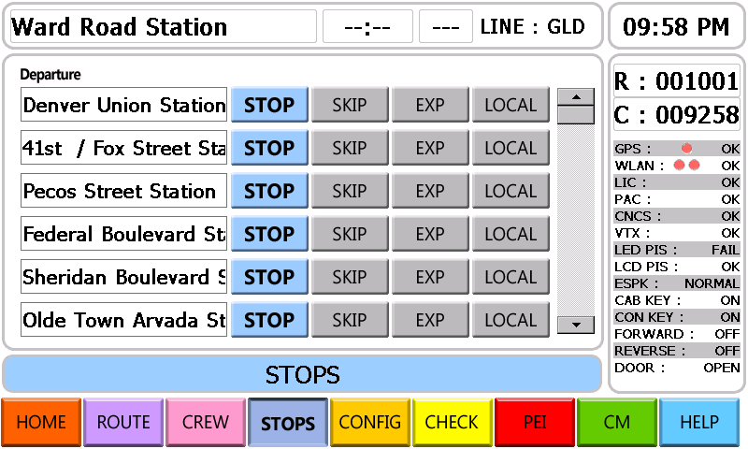
- STOPS setting
STOP :It transmits an automatic announcement.
SKIP : It does not transmit the automatic announcement.
EXP : It is considered as “SKIP” from the terminal to the selected station.
LOCAL : It is considered as “STOP” from the terminal to the selected station.

6. Configuration Initial Screen
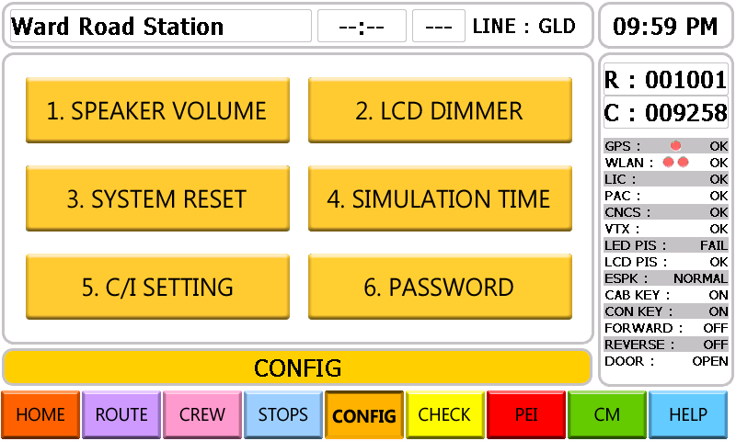

7. Interior / Exterior Speaker Volume Setting (* to be password protected)
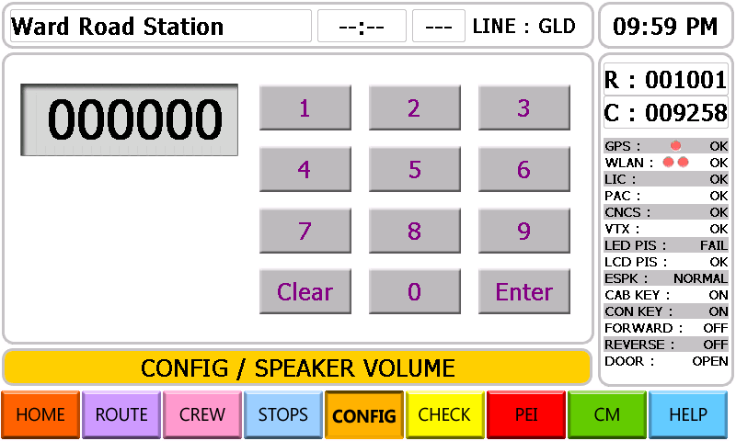

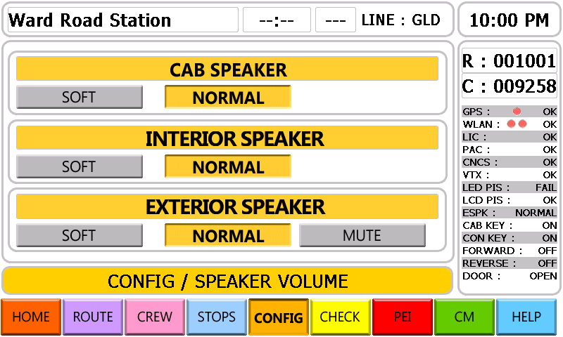

8. LCD brightness control
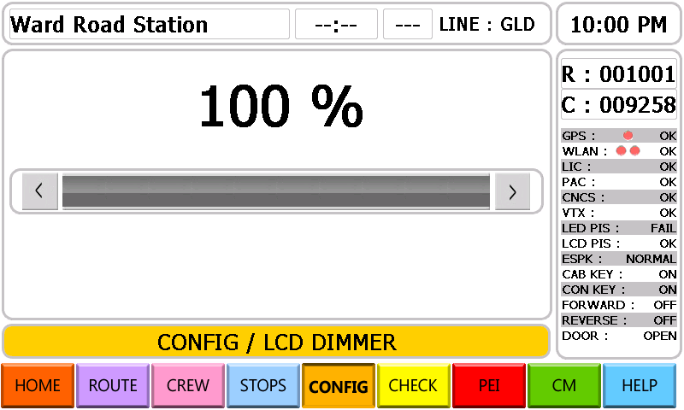

9. System initialization : pre-set Train Number / Crew ID initialization
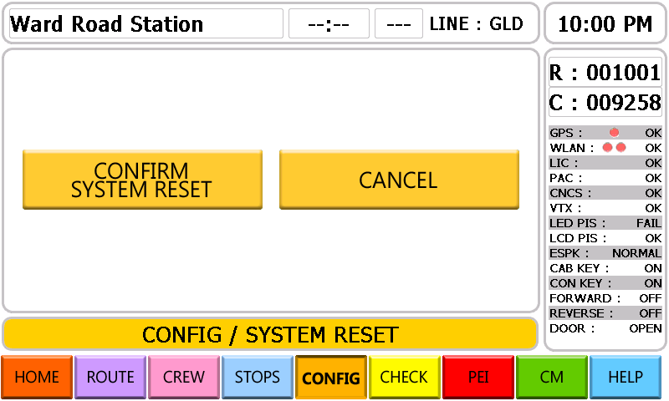

10. Simulation Interval Setting
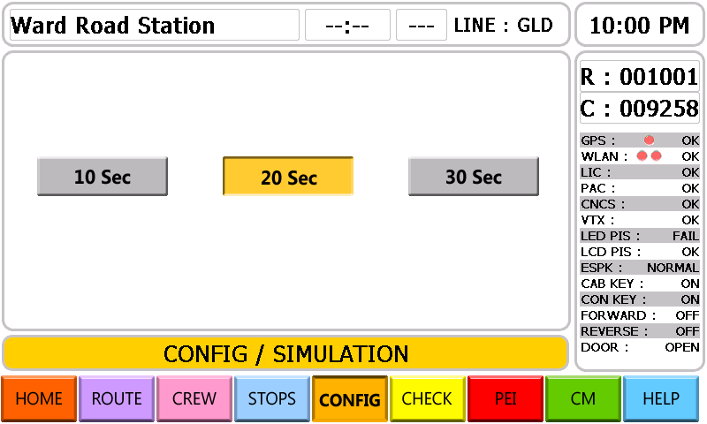

11. C/I number setting(* to be password protected)
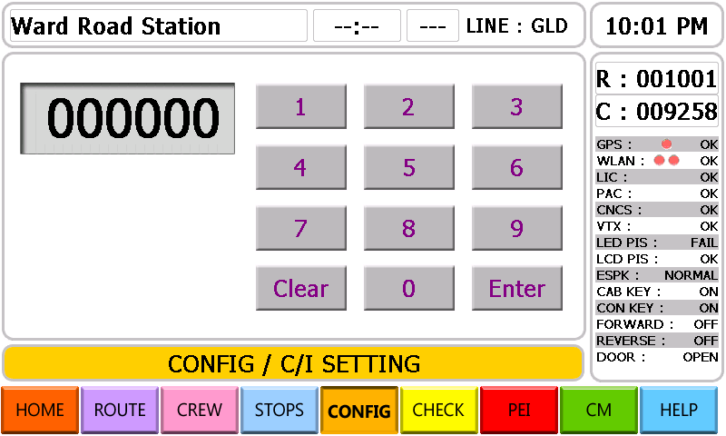

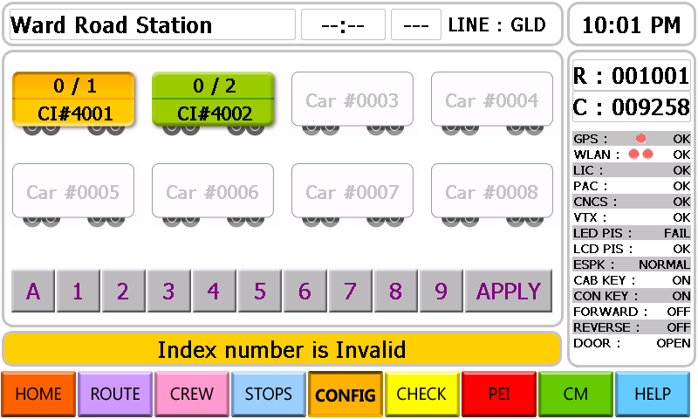

12. Change Password Screen
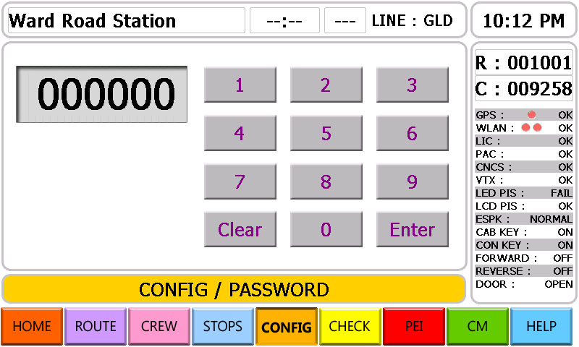

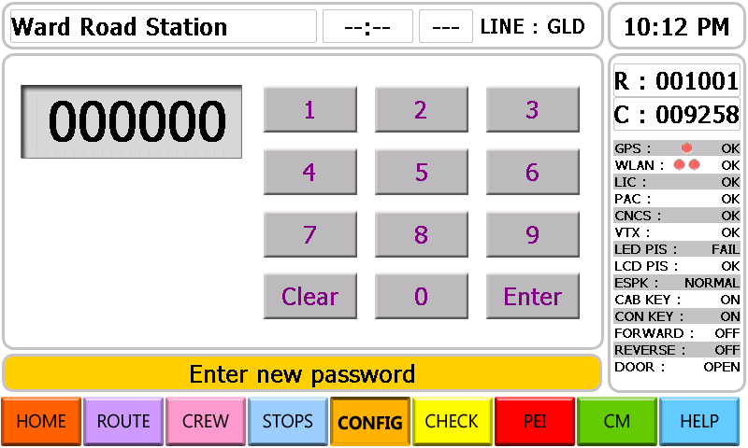

13. Vehicle failure information display
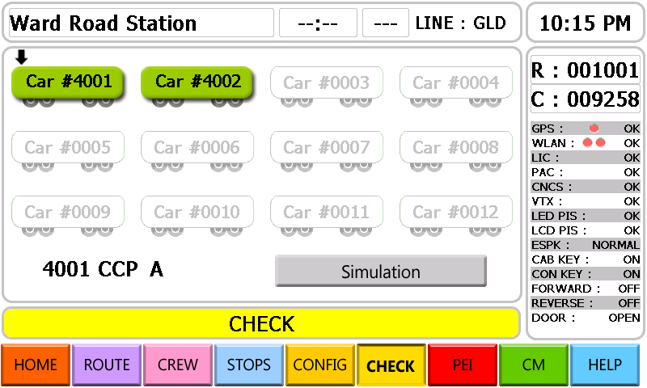
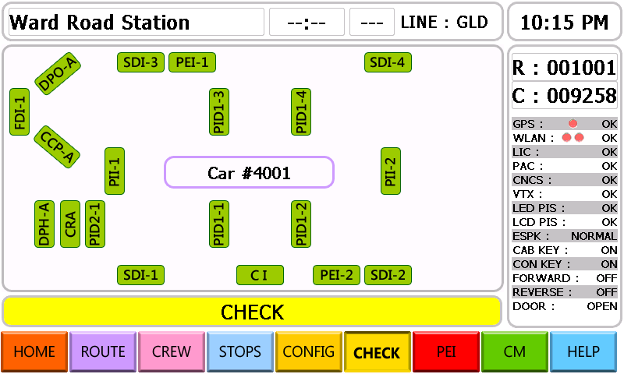

A vehicle without any failure information will be displayed with green color, but a vehicle including failure information will be displayed in red.

13.1 Married A vehicle failure information display
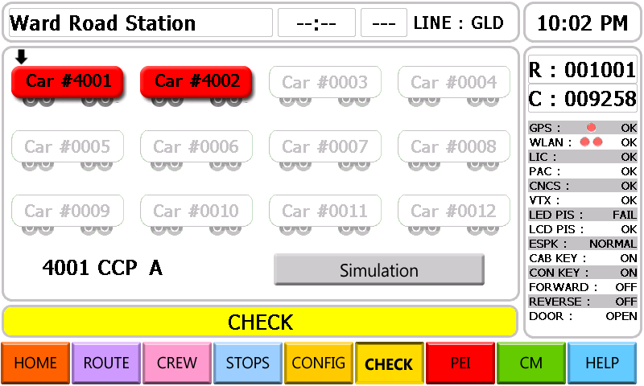
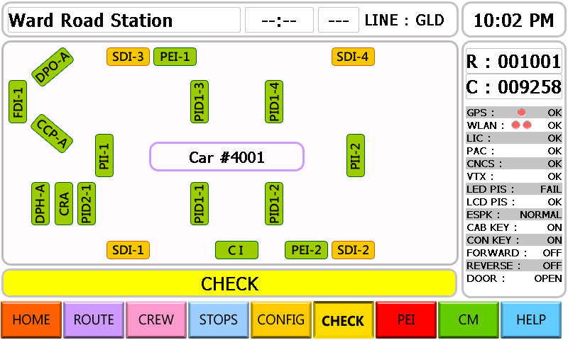
- Equipment which has failure will be displayed in yellow color.

13.2 Married B vehicle failure information display
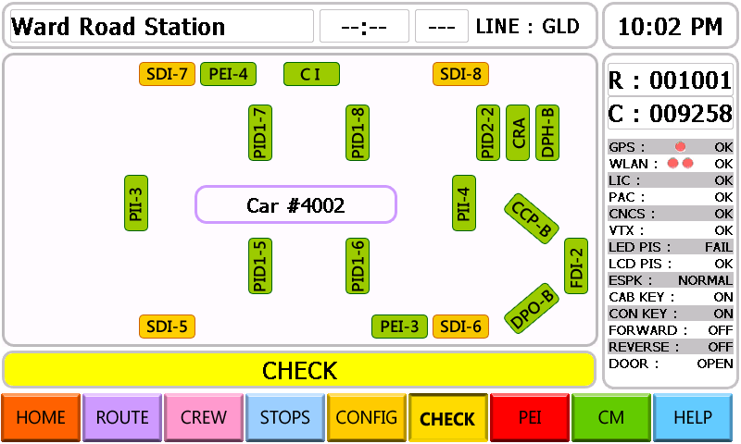

14. HELP Initial Menu Display
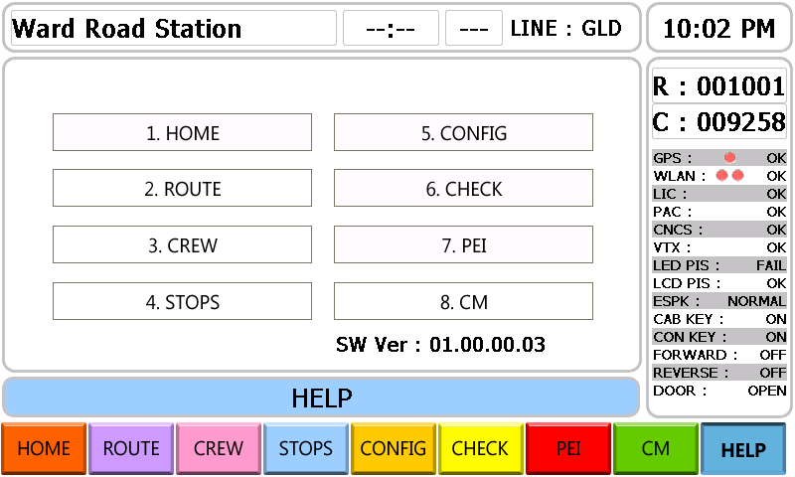

14.1 HELP on the HOME screen
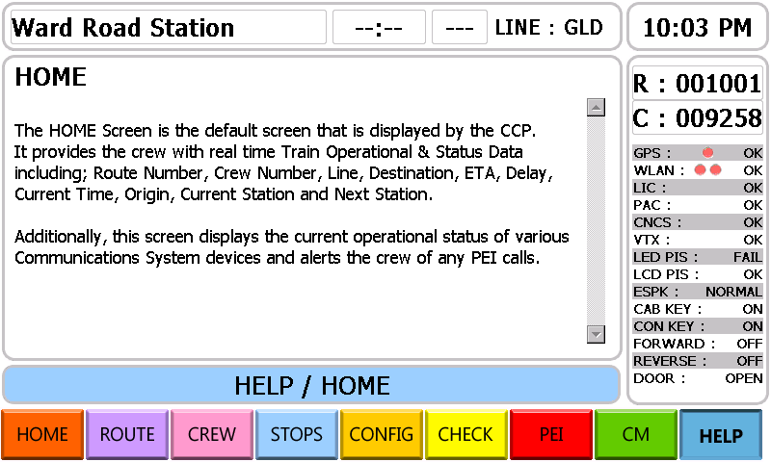

14.2 HELP on the ROUTE screen
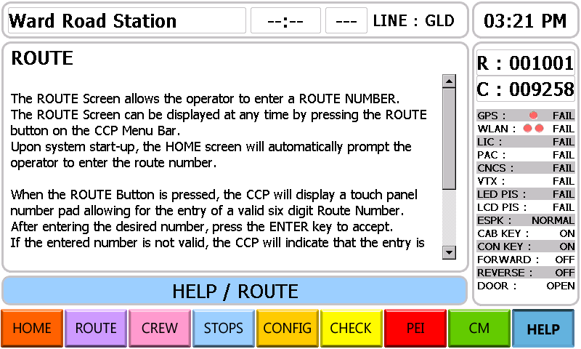

14.3 HELP on the CREW screen
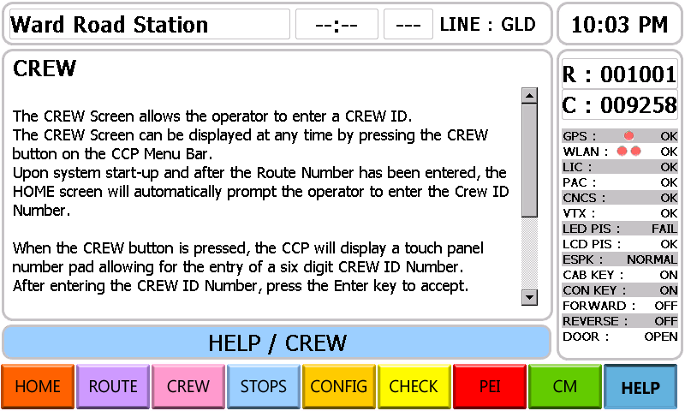

14.4 HELP on the STOPS screen
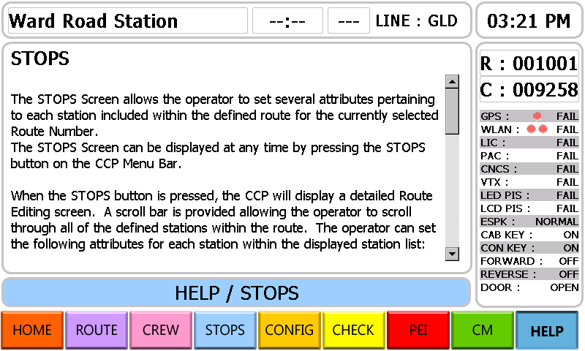

14.5 HELP on the CONFIG. screen
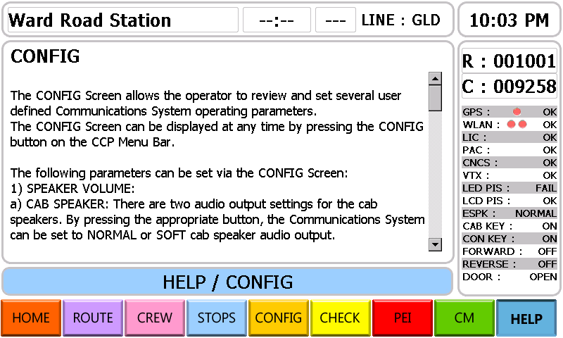

14.6 HELP on the CHECK screen
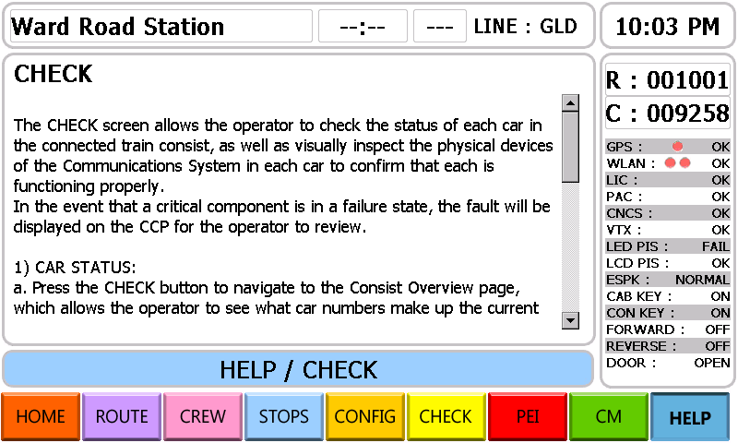

14.7 HELP on the PEI screen
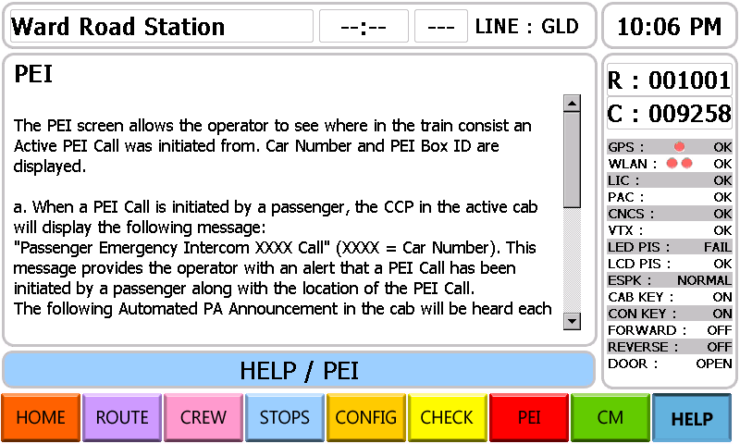

14.8 HELP on the CM screen
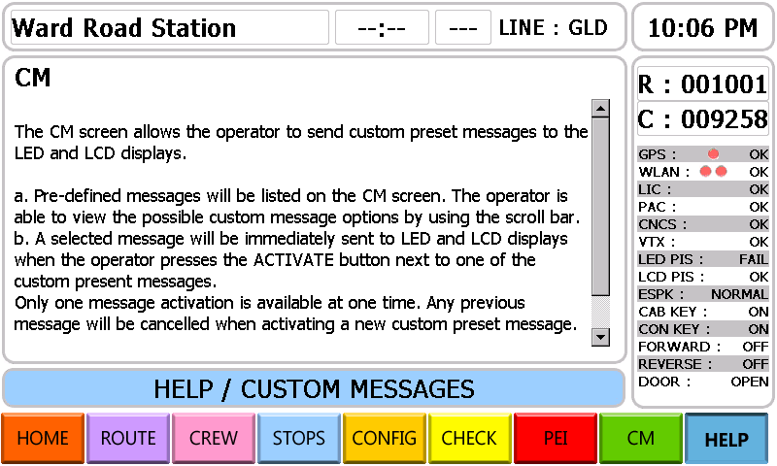

15. PEI initial screen
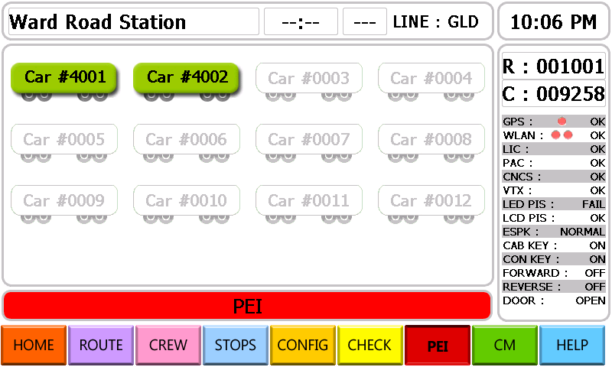
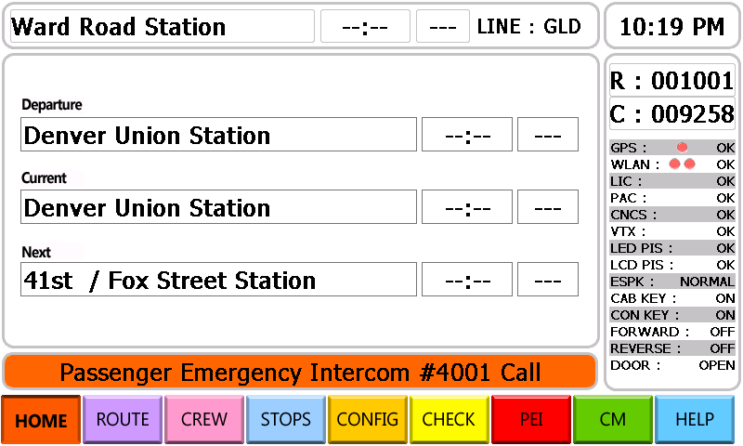
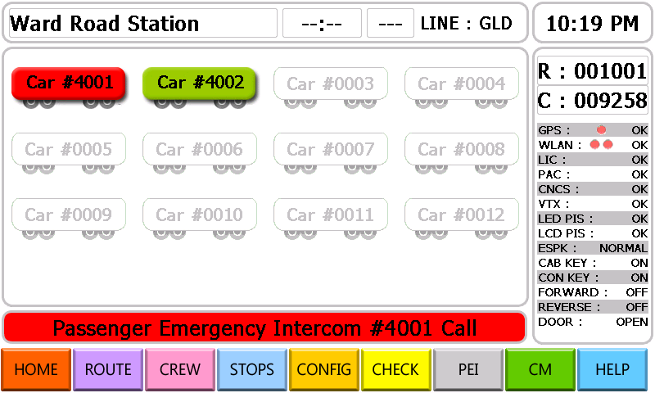
It is displayed a vehicle without PEI CALL in green and a vehicle with PEI CALL in red.

15.1 PEI CALL display of Married A
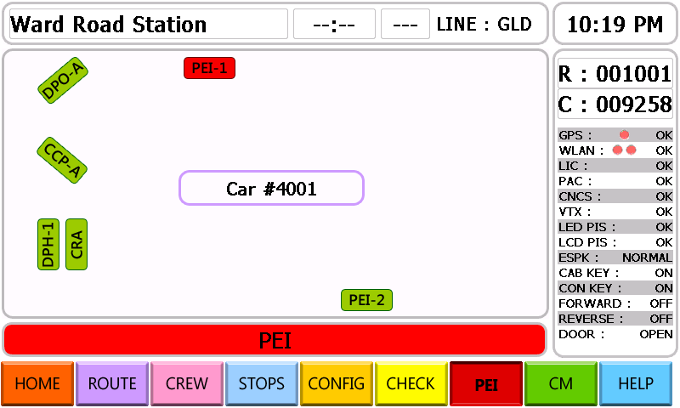
- PEI unit which has been pressed or called will be displayed in red color.

15.2 PEI CALL display of Married B
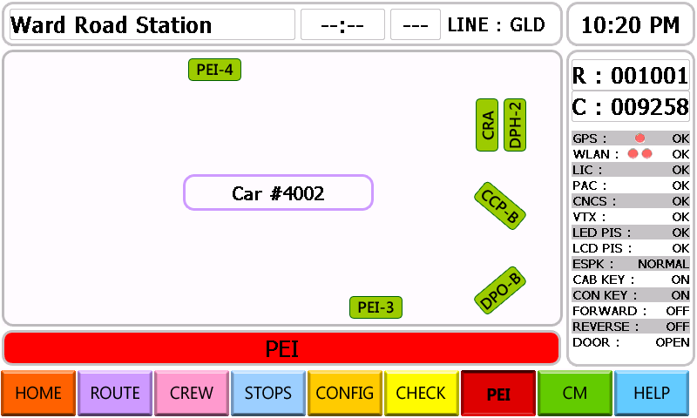

16. PR information display
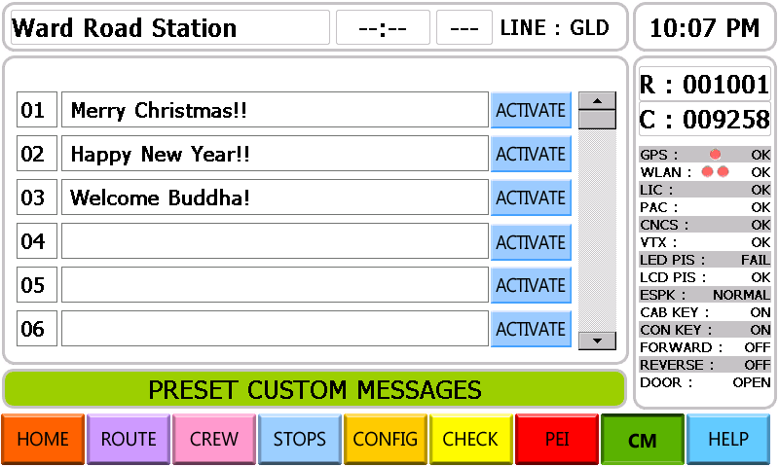
- A user-selected one of listed messages will be displayed on the indicator.

17 Simulation Mode Display
